22ISR034

Prasannakumar J M

TASK:3

CREATING A MINIKUBE SERVICE TO HANDLE CINTAINERS

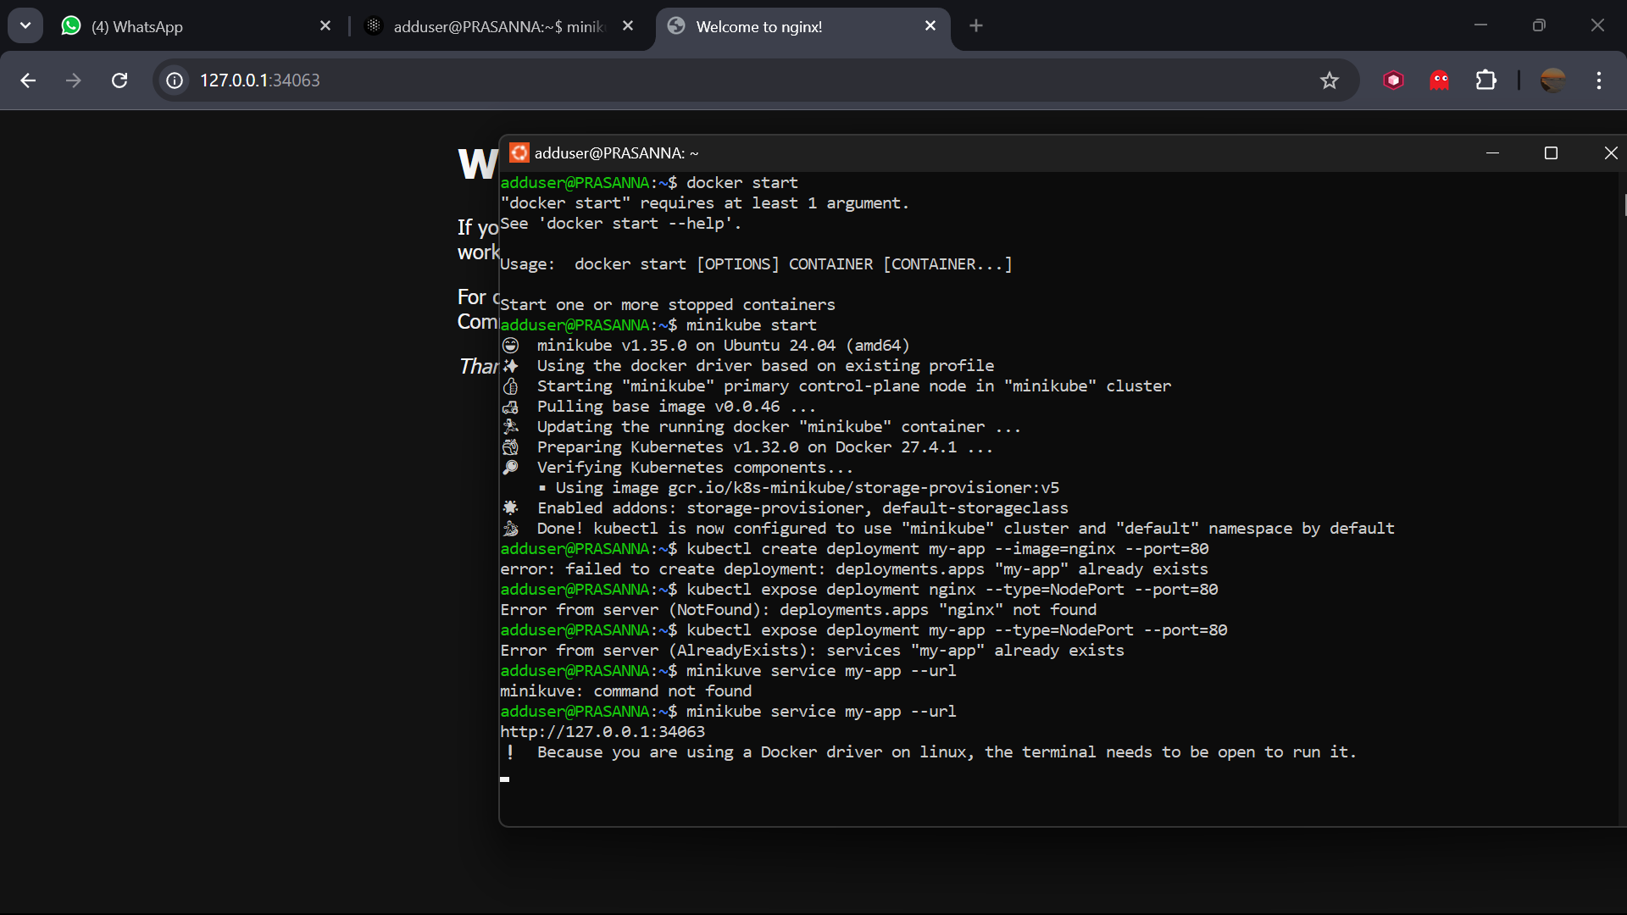

Output

